

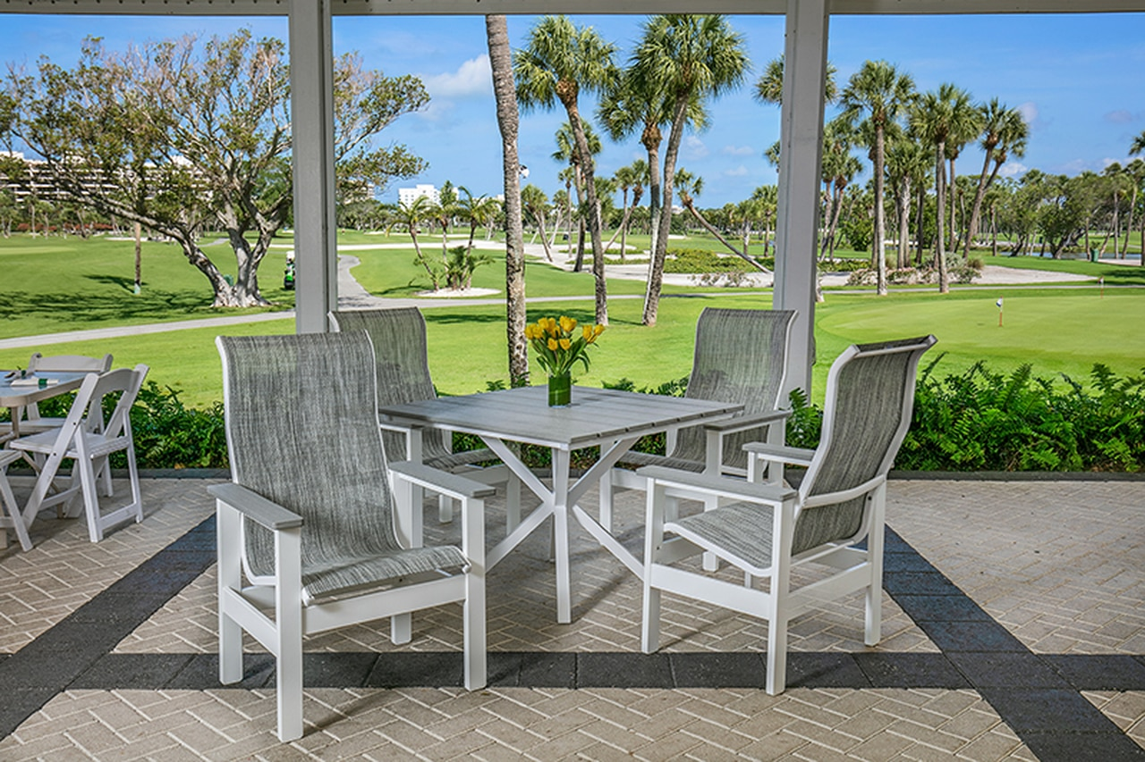





Full Exposure 100% USA Made Create Your Own

**SAFETY, CARE, MAINTENANCE & WARRANTY INFORMATION**

**2021 - 2022**

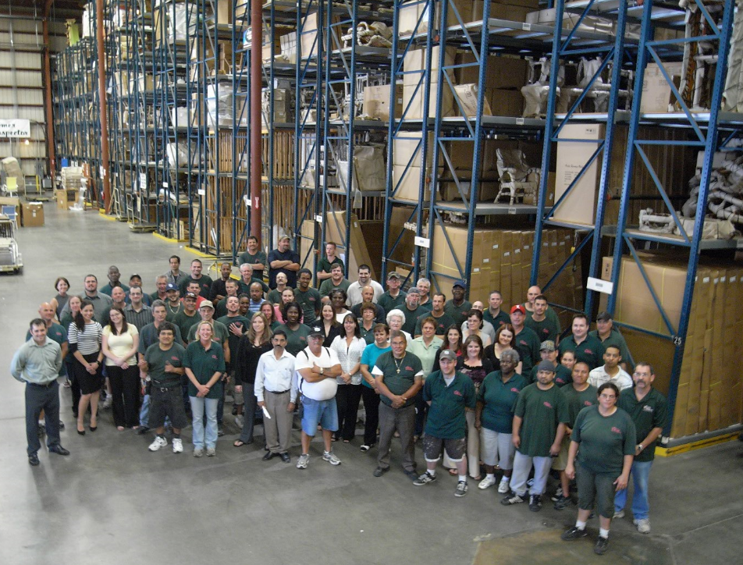

Thank you for allowing Leaders Furniture® and Windward® to be a part of your home. We are known for distinctive styles that can be customized to be uniquely yours. Our number one company goal, “A happy customer the first time,” extends beyond the sale with lifetime free phone support throughout your ownership. We want you to get the best experience from your purchase.

We understand that you could have decided to work with another company. Our reputation is important to us. Please take a moment to post your honest opinion of our service & product and post it online. Bring a copy of the posting to any retail location to receive 50% off an accessory item. An accessory item is a lamp, wall hanging, rug, or item that can be set on a table. An accessory item does not include umbrellas, ottomans, occasional chairs, tables, or any other furnishings.

Store locations: <http://leadersfurniture.com/locations/>

Website [leadersfurniture.com](http://www.leadersfurniture.com)

Solutions Center [solutions.center@leadersfurniture.com](mailto:solutions.center@leadersfurniture.com)

Distribution Center [leaders@leadersfurniture.com](mailto:leaders@leadersfurniture.com)

Social Media [Facebook icon](https://www.facebook.com/leaders.furniture)  [Twitter icon](https://twitter.com/leaderscasual)  [Instagram icon](https://www.instagram.com/leadersfurniture/)  [Pinterest icon](https://www.pinterest.com/islandwayliving/)

Thank you for the opportunity,

Tim Newton

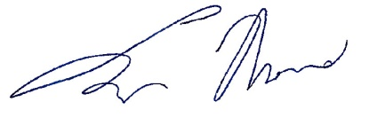

President



Table of Contents

Introduction 4

The Difference 5

Handcrafted 5

Hardware 5

Material 5

Construction 5

Safety 5

Product Inspection 5

Windy Conditions 6

Contract Installation Notice 6

Cleaning and Care 7

Cushions 8

Service / Ordering Parts 8

Warranty 9

File a Warranty Claim 11

# Introduction

At Windward Design Group, we understand that your outdoor living area is more than a place to sit, it’s an extension of your home, an extension of you. It is a place to relax, a place for celebrations, a place of romance and a place full of memories. Our goal is to assist you in getting the most out of your outdoor living area by furnishing that space with stylish, high quality products at a competitive price. We stand behind our products with pride and our warranty is confirmation of our confidence in the lasting quality of our products. With our broad line of collections, extensive outdoor fabric offering, beautiful frame finishes & unique embellishment options, it’s easy to customize our products to your individual style.

Windward Design Group uses the highest quality materials available for outdoor furniture manufacturing.  All of our furniture is manufactured with commercial-grade, domestically milled, extruded aluminum. Many of Windward’s extrusions are proprietary and have internal reinforcing ribs to provide the additional strength expected when purchasing a quality, domestically manufactured piece of outdoor furniture.

From stainless steel hardware that will never rust or corrode, to our custom fit nylon glides that are color coordinated with our frame finishes, our  attention to detail is reflected in each & every piece of furniture that we manufacture. Another detail we incorporate into our manufacturing process is full circumference, heliarc welds for added strength and durability.

To ensure lasting color and quality, our frames are sandblasted to create an ideal bonding surface.  This sandblasting preparation ensures your powder coated finish will not peel, or chip. Once the frame has been prepared, a fine powder paint is oven-baked at temperatures reaching 400 degrees fahrenheit to ensure even, complete coverage. Our experienced staff works with only the most reputable powder suppliers to create the best quality mixture of powders to create consistent, beautiful outdoor frame finishes.

Windward Design Group’s strap collections are designed with the ever demanding elements of nature in mind. We use 100% virgin, 2” vinyl and our strap pieces are doubled wrapped  around the frame and fastened with nylon solid shank rivets, creating a stronger hold with enhanced reliability. We offer almost four dozen strap colors, unlimited color combinations, and numerous customization options. In addition, many of our strap chaises include a safety feature to avoid finger pinching when adjusting the head rest position. We also offer many chaise seat heights... 14.5”, 16” & even 18”!  So, no matter the application... whether your customer requires furniture for their beach concession, backyard pool, or retirement community, we have a strap collection to suit their needs.

Windward’s comfortable sling collections will enhance any outdoor setting. Sling combines versatile style with easy cleaning and maintenance, perfect for any atmosphere, residential or commercial. All of our sling pieces are double stitched for added strength and we offer numerous sling fabrics to choose from. In addition, our padded sling offers that step up in comfort with durable padding added to the seat and back. By adding a pad to your sling, the design possibilities really multiply!

Windward Design Group’s outdoor cushions are designed to be more than just a pretty face, they are designed to handle the unexpected things that life brings. So sit back, relax and put your mind at ease knowing that our outdoor cushions surpass the highest quality and flammability standards issued for the furniture industry. Our deep seating collections & wicker replacement cushions are filled with our exclusive ComfortFLEX®  brand material, which provides an inviting, comfortable seat that won’t lose its loft. Our cushions are also completely customizable, with almost two hundred outdoor fabrics and many unique outdoor trim options to choose from, we are confident that our cushions will bring charm and allure to any outdoor setting.

We are proud to say that our frame preparation, finish processes, finish materials and ComfortFLEX®  materials are environmentally friendly.

We would be remiss if we didn’t mention one of our most valuable assets as a company and that is our people...our Windward Family!  We truly have one of the most outstanding group of dedicated, hard-working, knowledgeable, ever-improving, and dependable staff.  Thank you for the opportunity to provide you with not only quality outdoor furniture, but also to keep a wonderful ‘MADE IN THE USA’ story going. Welcome to our family!

# The Difference

## Handcrafted

Skilled American craftsman make, sew and assemble each component.

## Hardware

Attention to detail is reflected in each & every piece of furniture manufactured. 360 or better stainless hardware is used for added strength and durability along with nylon glides for floor protection and ease of movement. Windward® lasts in every situation including marine exposure.

## Material

Only the highest quality, commercial grade, domestically milled, extruded aluminum materials (i.e., aluminum, stainless steel and polyethylene) that are capable of withstanding tropical marine exposure are used to construct Windward® products. These durable materials make the product easy to maintain and easy to own.

## Construction

Windward does not settle for just a chemical prewash before powder coating. Their quality process begins with every part being thoroughly sandblasted to ensure the best finish adhesion. All products are then assembled by skilled American craftsman with 360⁰ welds, nylon glides, and if hardware is used, it is stainless steel.

# Safety

In our continuing effort to ensure that your experience with your new purchase is positive with regard to comfort, quality and design, we take safety very seriously. Please note the following important safety information, in addition to any other safety information noted in this booklet.

Safety Warning! Use of furniture in need of care and maintenance or use of damaged furniture can result in injury. Minor repair issues, if unaddressed, can become major repair and service issues that can create potential safety issues. Contact the Leader Furniture® Solutions Center for support at [solutions.center@leadersfurniture.com](mailto:solutions.center@leadersfurniture.com)

## Product Inspection

Periodically and carefully inspect all products for breakage and/or indications of wear. Inspections must include, but not be limited to, joint tightness, spring assemblies, and the weld areas of the product’s, arms and legs. If joints are loose or any cracks should appear on the product or at welds, the item must immediately be removed from service until repaired.

Inspections must include all bolts and screws. Should any loose or missing hardware be detected, the item must be removed from service immediately until the hardware can be properly tightened and/or replaced.

Inspections must include chaise lounge and recliner headrest ratchets. Periodically tighten the headrest bolts on all chaise lounges and recliners. Confirm all other hardware is tight, movement is smooth without binding, and that the ratchet engages properly at each position. At the same time, carefully inspect the headrest ratchets for breakage and/or wear. If headrest ratchet breakage and/or indications of headrest ratchet wear are present, a replacement headrest should be ordered. The furniture must immediately be removed from service until repaired and/or replacement parts installed.

To obtain replacement parts, please see the SERVICE / ORDERING PARTS AND ACCESSORIES section of this brochure.

Product failure caused by a lack of reasonable and necessary care and maintenance is not covered by the product warranty.

Contact the Leaders Furniture® Solutions Center immediately if you notice concerns. [solutions.center@leadersfurniture.com](mailto:solutions.center@leadersfurniture.com)

Safety Warning! Chaise lounge and recliner headrests must NEVER be adjusted while seated in the chaise. Serious finger, hand or other bodily injury may result from adjusting the headrest while seated. Headrests must always be adjusted while out of the furniture and standing to the side.

## Windy Conditions

Safety Warning! During windy conditions, chaise lounge and recliner headrests may be blown forward, possibly resulting in head, neck, facial, arm and/or back injuries. During windy conditions the headrests must be lowered to the fully down position. The use of the chaise lounges and recliners must be discontinued and users should leave the area.

Notice for contract installations:

## Contract Installation Notice

Periodically and carefully inspect all products for breakage and/or indications of wear. Such inspections must include all products of a like kind and model, not merely a random sampling within model categories or among like products.

Regular random inspections of a sampling within model categories and among like products must be undertaken in addition to the periodic inspections of all products.

* Chaise lounge
* Recliners
* Swivel tilt motion chairs
* Rocking chairs

Include the following or substantially similar conspicuous written notice as part of the posted Rules and Regulations at poolside, and elsewhere wherever chaise lounges and recliners are available for use:

* 1. "Never adjust chaise lounge or recliner headrests while seated. Serious finger, hand or other bodily injury may result from adjusting headrest while seated."
  2. "During windy conditions, the use of the chaise lounges and recliners must be discontinued and users should leave the area."

Consider also including such notice in the written material(s) provided to guests in connection with the availability and use of the guest amenities at your facility.

Contact the Leaders Furniture® Solutions Center immediately if you notice concerns. [solutions.center@leadersfurniture.com](mailto:solutions.center@leadersfurniture.com)

# Cleaning and Care

## Cushions

After a soaking rain or anytime the cores of the cushions get wet, it is best to stand the cushion on end to allow them to drain more quickly. This will prevent mold and mildew growth between the frame and the cushion.

Spot wash the fabric to clean spills by using a sponge or a soft bristle brush with a warm soapy solution of mild detergent (Joy or Ivory liquid). Brush or sponge the soiled area and rinse thoroughly with fresh water. Allow to air dry. Repeat if necessary.

**DO NOT MACHINE WASH OR MACHINE DRY THE CUSHION CASINGS. YOU COULD DAMAGE THE SEAMS OF THE CASE.**

**If and only if your cushion is made from 100% solution dyed acrylic such as Sunbrella®, you may use 1-part bleach mixed with 1-part water and mild dish soap to clean your cushions. Check a small inconspicuous spot for color fastness before cleaning the entire cushion. Be sure to rinse the cushion thoroughly to remove all the bleach solution.**

# Service / Ordering Parts

After a safety inspection or at any time during your ownership, please contact the Leaders Furniture™ Solutions Center to order replacement parts or to discuss any concerns you may have at: [solutions.center@leadersfurniture.com](mailto:solutions.center@leadersfurniture.com).

|  |  |  |
| --- | --- | --- |
| **Warranty** – After 10/2019 | | |
|  | **Residential** | **Commercial** |
| Features Covered | **Years Covered** | **Years Covered** |
| Extruded Aluminum Frame- material defects and workmanship | 10 Years* | 5 yrs. from date of delivery (bolt-thru bracing is required on some collections) |
| Wicker Aluminum Frame - material defects and workmanship | 4 Years* | 2 Years* |
| Resin Wicker (Woven Products) - discoloration and splitting | 3 Years* | 1 Year* |
| Marine Grade Polymer Frames, Components and Tabletops - material defects, workmanship, discoloration and cracking | 10 Years* | 5 Years* |
| Powder Coated Frame Finishes (frames & table bases except wicker collections) - cracking, peeling and blistering | 7 Years* | 3 Years* |
| Powder Coated Wicker Frame Finishes - cracking, peeling and blistering | 3 Years* | 1 Year* |
| Vinyl Strapping- breakage and rivet failure and abnormal discoloration | 2 Years* | 2 Years* |
| Fire Pit Hardware- manufacturer defects to the burner, bowl, gas valves, hoses, wires and igniter | 1 Year* | 1 Year* |
| Slings, Padded Slings, Oxford woven Foam Fill, Cushions and Fabric** - manufacturer defects: fabric/sewing integrity and cushion/pad fill | 1 Year* | 1 Year* |
| Umbrellas- covers and frames | 1 Year* | 1 Year* |
| Tabletops (except glass) - warping and manufacturer defects | 1 Year* | 1 Year* |

*All warranties are from the original first delivery to the original purchaser. Warranted time frames do not start over for any subsequent delivery of product replaced for any reason. Warranties only cover the original purchaser and are void upon ownership transfer.

**\*\***Some fabric mills warranty their fabric for 5 years. If your cushions are made by fabric from one of these mills and the mill finds the fabric to be defective, the mill will supply us with fabric to make the new covers for your cushions. If you would like completely new cushions made, you may choose to pay for new foam cores while the covers are being remade. Dye lot variation results in color differences from bolt to bolt and may not match your fabric swatch or previous shipments.

|  |  |  |
| --- | --- | --- |
| Warranty – Before 10/2019 | | |
| Residential | | **Commercial** |
| Features Covered | **Years Covered** | **Years Covered** |
| Extruded Aluminum Frame - material defects and workmanship | 15 yrs. from date of delivery | 5 yrs. from date of delivery (bolt thru bracing is required on some collections) |
| Cast Aluminum Furniture | 3 yrs. from date of delivery | 1 yr. from date of delivery |
| Wicker Frame (Woven Products) - material defects and workmanship | 5 yrs. from date of delivery | 3 yrs. from date of delivery |
| Wicker Frame (Woven Products) - discoloration and splitting | 3 yrs. from date of delivery | 1 yr. from date of delivery |
| Marine Grade Polymer Frames, Components and Tabletops - material defects, workmanship, discoloration and cracking | 15 yrs. from date of delivery | 5 yrs. from date of delivery |
| Vinyl Strapping - breakage and rivet failure and abnormal discoloration | 3 yrs. from date of delivery | 3 yrs. from date of delivery |
| Fire Pit Hardware - manufacturer defects to the burner, bowl, gas valves, hoses, wires and igniter | 1 yr. from date of delivery | 1 yr. from date of delivery |
| Slings, Padded Slings, Oxford woven Foam Fill, Cushions and Fabric* - manufacturer defects: fabric/sewing integrity and cushion/pad fill | 1 yr. from date of delivery | 1 yr. from date of delivery |
| Umbrellas - covers and frames | 1 yr. from date of delivery | 1 yr. from date of delivery |
| Tabletops (except glass) - warping and manufacturer defects | 1 yr. from date of delivery | 1 yr. from date of delivery |

*All warranties are from the original first delivery to the original purchaser. Warranted time frames do not start over for any subsequent delivery of product replaced for any reason. Warranties only cover the original purchaser and are void upon ownership transfer.

**\*\***Some fabric mills warranty their fabric for 5 years. If your cushions are made by fabric from one of these mills and the mill finds the fabric to be defective, the mill will supply us with fabric to make the new covers for your cushions. If you would like completely new cushions made, you may choose to pay for new foam cores while the covers are being remade. Dye lot variation results in color differences from bolt to bolt and may not match your fabric swatch or previous shipments.

## File a Warranty Claim

We are here to help you after the sale. To help us process your claim as fast as possible please complete the following steps.

**Step 1:** Take a picture of each item with a concern in a format that you will be able to attach to an email.

1. Take a picture of the entire item with a concern
2. Take a close-up picture of the concern
3. Repeat for every item with a concern

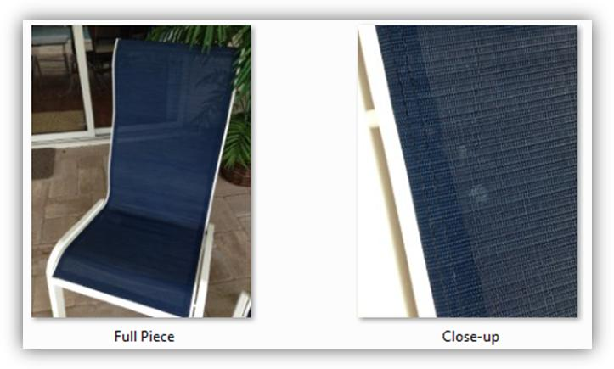

**Step 2:** Send a text to (727) 346-8528 or email to [solutions.center@leadersfurniture.com](mailto:solutions.center@leadersfurniture.com)and include the following

* Your name
* Phone number
* How many items you have a concern with
* A description of each concern
* A picture of each item and a close up of each concern

**Step 3:** One of our Solutions Center Representatives will get back to you within 24 hours. If you do not hear back for any reason within 24 hours, please contact us toll free at

(877) 538-5783.